**Term 2- It’s Learning ASSIGNMENT 2- YOUR STUDY ABROAD**

## 01 Vocabulary

During your education you might come in contact with people from different countries, maybe you will do an international project, do an internship abroad or join an exchange programme. It helps to know what different schools are called in English.

Translate the following words into English. With some Dutch words, you can have two English translations.

Place the correct English translation into the right side of table below and add the completed table to your portfolio.

* Vocational Education
* University
* University of applied sciences
* *Pre-university*
* *Primary school*
* *Senior General secondary education*
* *Higher professional education*
* *Community college*
* *Pre-vocational secondary school*

|  |  |
| --- | --- |
| 1. Basisschool |  |
| 1. VMBO |  |
| 2. HAVO |  |
| 3. VWO |  |
| 4. MBO |  |
| 5.HBO |  |
| 6. WO |  |

**02 Reading**

Read the text and answer the questions on the right? Discuss in class or ask your teacher if you don't know one of the answers.

Bron: https://learnenglishteens.britishcouncil.org/skills/reading/intermediate-b1-reading/foreign-exchange-emails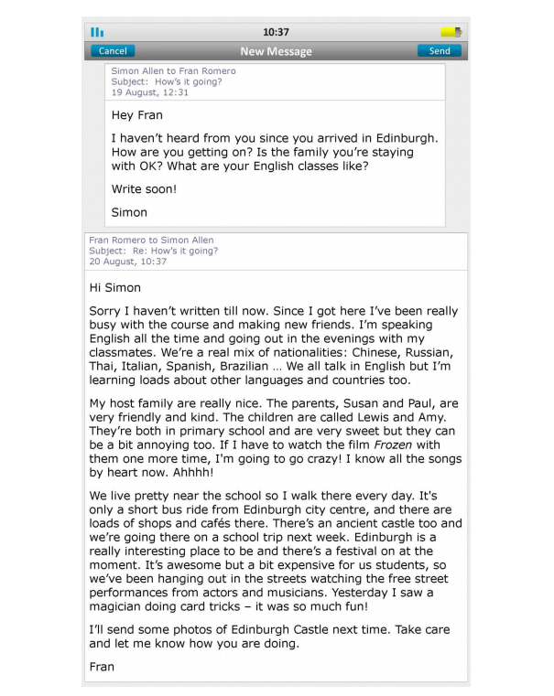

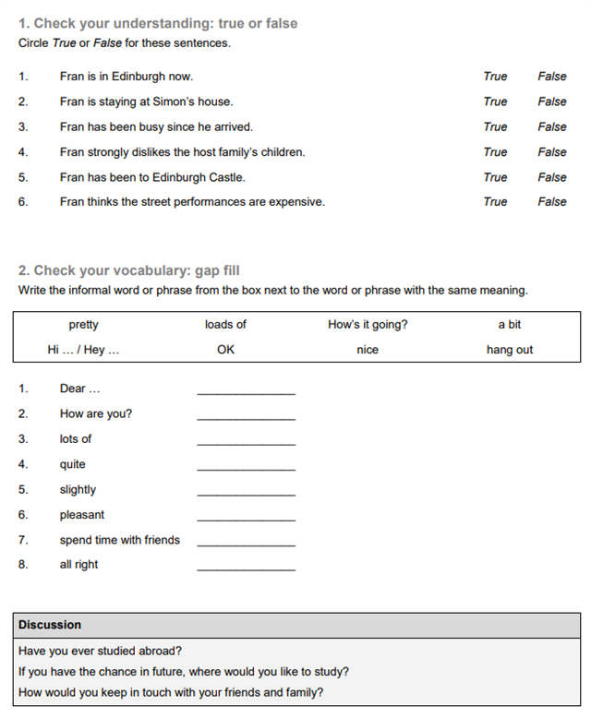

## 03 Listening

The following excercise is about listening. First do the preparation question then listen to the audio-file and do the matching exercise. If you don't know one of the answers check with your fellow students or your teacher.

Bron: <http://learnenglishteens.britishcouncil.org/skills/listening/intermediate-b1-listening/celebrations>

|  |
| --- |
| https://files.itslearning.com/data/459/63711/exercises%20preparation%20listening%20celebrations%20british%20council.png |
| -04:17  [B1_celebrations.mp3](https://files.itslearning.com/data/459/63711/Uw%20opnames/B1_celebrations.mp3) |
| https://files.itslearning.com/data/459/63711/exercises%20matching%20listening%20celebrations%20british%20council.png |
|  |

Source: <http://learnenglishteens.britishcouncil.org/skills/listening/intermediate-b1-listening/celebrations>

## 04 Internship abroad

In your study you might want to do an internship abroad. For this assignment go to the following website:

<https://abroad-internships.nl/stages>

1. Search for an internship for your study

2. Write an email

* Use the right salutation (aanhef)
* Write something about yourself (name, age, what you study, .....)
* Give 2 reasons why you are perfect for the internship
* Use the correct closing (afsluiting)

Add the email to your digital portfolio and hand it in [**HERE**](https://davinci.itslearning.com/TreeLinks?id=dc34f685-ff21-4091-94f0-3edef7359110&sourceElementId=1303344)

*Do you remember how to start or end an email? If not -->*

[*https://www.speaklanguages.com/english/phrases/writing-letters-and-emails*](https://www.speaklanguages.com/english/phrases/writing-letters-and-emails)

[*https://educatie-en-school.infonu.nl/buitenlands/55454-de-indeling-van-een-engelse-brief.html*](https://educatie-en-school.infonu.nl/buitenlands/55454-de-indeling-van-een-engelse-brief.html)

## <https://www.speaklanguages.com/english/phrases/writing-letters-and-emails>

**WRITING AN INFORMAL LETTER**

Start your letter by using the word Dear followed by the first name of the person you're writing to, for example:

* Dear Mark,
* Dear Jane,

Here are some things you might say:

- Thanks for your … (letter/ postcard/ present/ invitation )

- Sorry it's taken me so long to write.

- I hope you're well.

- Good to see you again last week.

- Look forward to seeing you soon!

Here are some typical ways to finish an informal letter:

* Best wishes,
* Kind regards,

If writing to a family member, partner, or close friend, you can finish with the following: Love,

**Finish by signing your first name.**

## WRITING AN EMAIL

Emails, whether for business or social reasons, are usually written in a more informal style than letters.

You should always give your email a Subject, which should summarise its purpose in a few words.

The conventions for starting business emails vary, although it is quite common to use first names for both business and personal emails if you know the recipient.

It is not necessary to use Dear, although some people prefer to do this.

Generally speaking, the content of business emails should be brief and to the point.

If you are including any attachments, make sure to mention it in the text of your email.

To close a personal email, you can use the same expressions as for informal letters.

The conventions for closing business emails vary, but phrases such as the following are appropriate:

* Regards,
* Kind regards,
* Best regards,
* With kind regards,

In business emails, you should also include your full name, organisation, and contact details at the end.

## WRITING A FORMAL LETTER

* If you know the name of the person you are writing to, start your letter by using
* Dear Mr (for a man),
* Dear Mrs (for a married woman),
* Dear Miss (for an unmarried woman),
* Dear Ms (for an unmarried woman or where the marital status is unknown),

followed by the surname, for example:

* Dear Mr Smith,
* Dear Mrs Jones,
* Dear Miss Richards,
* Dear Ms Shepherd,

If you don't know the name, start with one of the following:

* Dear Sir,
* Dear Madam,
* Dear Sir or Madam,

Here are some examples of things you might say in a formal letter:

* I am writing in reply to your letter of 4 September regarding your outstanding invoice.
* Further to our conversation, I'm pleased to confirm our appointment for 9.30am on Tuesday, 7 January.
* I would be grateful if you could attend to this matter as soon as possible.
* If you would like any further information, please don't hesitate to contact me.

If you would like a reply, you can use the following sentence at the end of your letter:

* I look forward to hearing from you.

If you started your letter with Dear Mr, Dear Mrs, Dear Miss, or Dear Ms, you should finish your letter with the following expression: Yours sincerely,

However, if you started your letter with Dear Sir, Dear Madam, or Dear Sir or Madam, then use the following: Yours faithfully,

Add your signature at the end, followed by your full name printed.

<https://educatie-en-school.infonu.nl/buitenlands/55454-de-indeling-van-een-engelse-brief.html>

**De indeling van een Engelse brief**

**Formele brief**

In een formele Engelse brief maak je geen gebruik van afkortingen. Je bent geneigd om afkortingen te gebruiken omdat dit makkelijker is of omdat je dit gewend bent. Don't, I'm, He's, She's, Can't, I'd like to...

Deze afkortingen zien er op het eerste gezicht niet slecht uit, maar als je zo'n brief schrijft naar een Engels bedrijf, dan wordt deze brief meteen weggegooid. Maak dus nooit gebruik van afkortingen. Schrijf dus: Do not, I am, He is, She is, Can not, I would like to..

Hierboven zie je dat Can't fout is en dat Can not goed is. Maar het woord 'can' staat niet netjes in een brief. Schrijf in plaats van 'can' het woord 'could'.

**Aanhef**

De indeling van een Engelse brief komt hierna aan de orde. Het is belangrijk om te weten hoe je iemand aanspreekt.

* Dear Mr Johnson, een getrouwde of een ongetrouwde man.
* Dear Mrs Cole, de vrouw is getrouwd of is ooit getrouwd geweest.
* Dear Miss Cole, de vrouw is niet getrouwd.
* Dear Ms Cole, je weet niet of de vrouw getrouwd is of niet.
* Dear Sir/Madam, je hebt geen naam van de persoon.

Gebruik geen punt achter Mr, Mrs etc. Voorbeelden als Mrs. Cole en Mr. Johnson zijn fout.

**Briefindeling**

* Je begint de brief met jouw adres, postcode en land. Maar schrijf nooit je naam bovenaan de brief, deze komt onderaan de brief.
* Na jouw naam komt de datum. Dit mag niet: 21-12-2009. De maand moet voluit worden geschreven. 21st December, 2010.
* Na de datum komen de gegevens van de geadresseerde.
* De aanhef, met een witregel erboven en eronder is dan aan de orde. Meestal bestaat de brief uit drie alinea's. Inleiding, kern en slot.
* Eindig een brief met: I am looking forward to a quick response. Dit gebruik als je wacht op een reactie.
* Groet met 'Yours sincerely' in een formele brief en gebruik **'Yours faithfully' in een informele brief.**

**Voorbeeld brief:**

Lange dijk 33

6788 AH Genemuiden

Netherlands

21st December, 2010

Maxell Audio

45 Grove street

Cambridgeshire

England

For attention of Ms Mayfield

Dear Ms Mayfield,

Subject: ..

Leg uit in alinea één waarom je schrijft.

Leg uit in alinea twee wat je wil bereiken.

Leg uit in alinea drie dat je hoopt op een snel antwoord.

(I am looking forward to a quick response)

Yours Sincerely,

(handtekening)

David de Jong (jouw naam)

Vergeet nooit je handtekening te zetten onder je naam. Zonder handtekening is het document niet geldig en kan er niks worden gedaan met je brief, hoe je goed je brief ook is.